Level I assignment/Extra Credit

Concept: Working with TEXT to create EMPHASIS

Pick a meaningful, positive, and encouraging quote. For example:
-"Those who stand for nothing fall for anything."
Alexander Hamilton

Both quotes deliver the same message but with slightly different wording. You, as high school students are faced with important decisions that define your character on a daily basis. You can decide to help someone, or walk by them. You can stand up for someone, or join your peers who tease or exclude another student. You can choose to speak up in a debate in class, or watch others participate.
What words stand out to you in your quote? How can you emphasize those words?

Assignment: Choose a quote. Browse online or use one of your favorites.
- Create an 11 x 17” poster (portrait or landscape) in Adobe Photoshop
- Limit yourself to no more than 3 different fonts
- Use size, color, style, and/or font to create emphasis on certain parts of the quote.
- This should be a visually powerful poster.
- No more than 75% of the poster may be filled with color/ink from the printer
- You must incorporate at least one photograph or design
- Pay attention to text alignment

Examples of text focused posters:
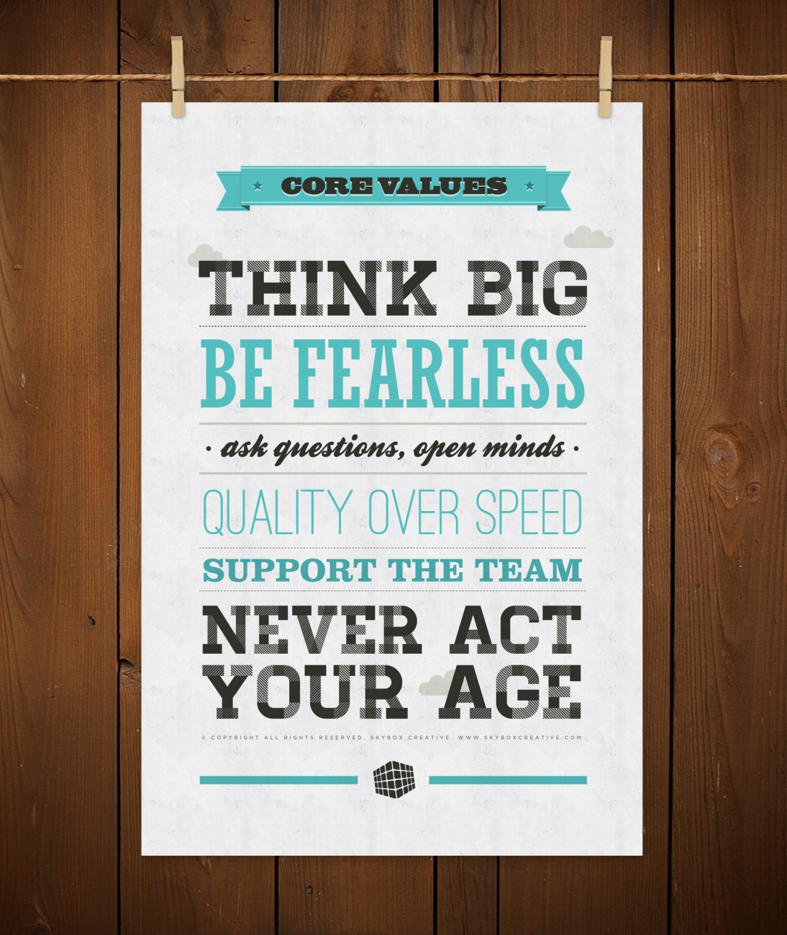
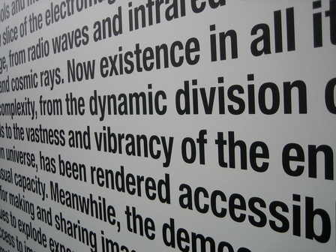 Using perspective

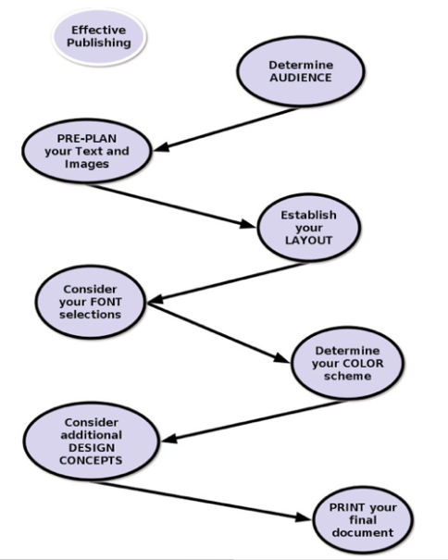 Using visual symbols to direct the eye

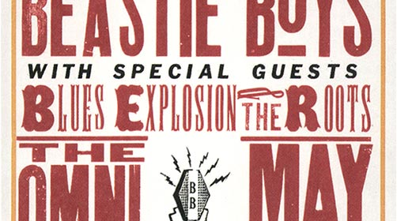Size, color, style
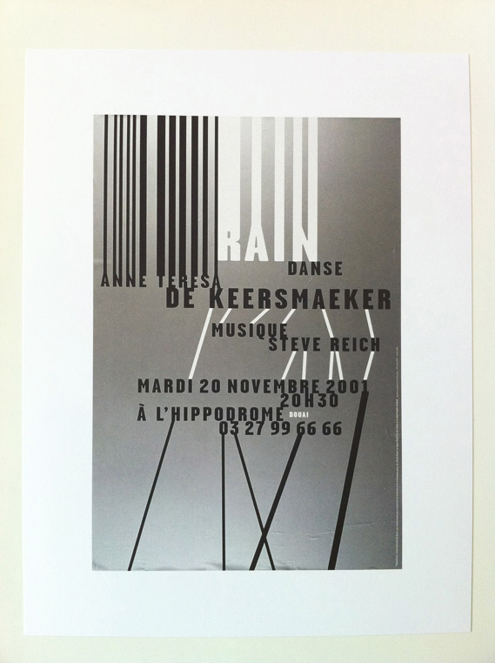 Space and arrangement

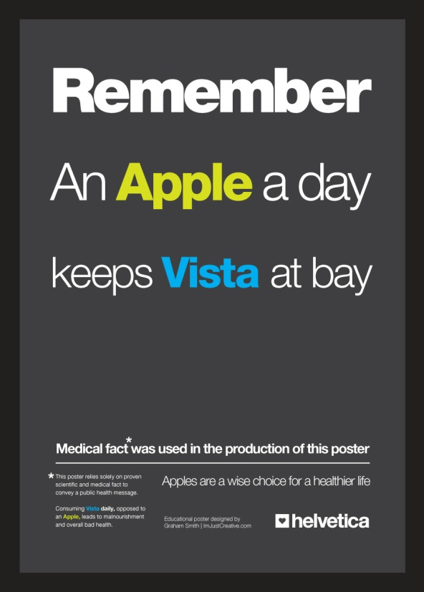 Color, style, line spacing

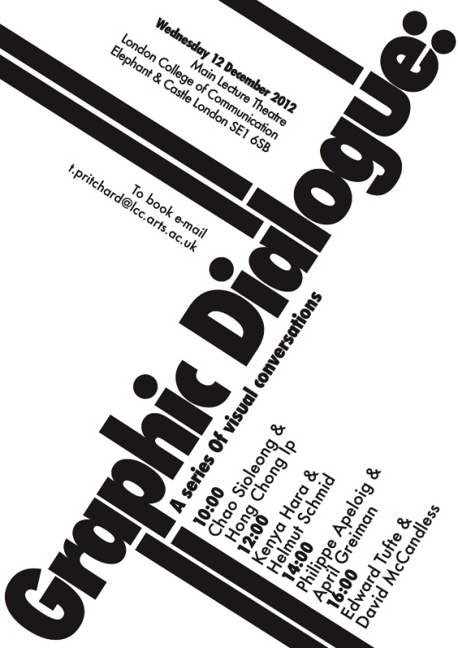 Text box orientation/diagonals

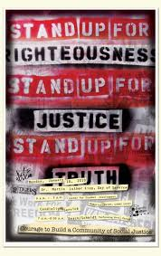 Alignment, font and style

